cloud computing
Lab 09

Name: Abiha Nadeem

Roll no: 2023-BSE-001

Submitted to: Engr. Muhammad Shoaib

Task 1 — GitHub CLI, Codespace setup and authentication
Goal: Install GH CLI (if not already present), authenticate with GitHub, create a Codespace, and connect to it. All work for the rest of the lab must be done inside the Codespace.
Steps (do these from your local machine shell first, then run codespace commands):
- (Local desktop) Install GitHub CLI (Windows example via winget):
winget install --id GitHub.cli
  - Save screenshot as: task1_gh_install.png — terminal showing the winget install command output.
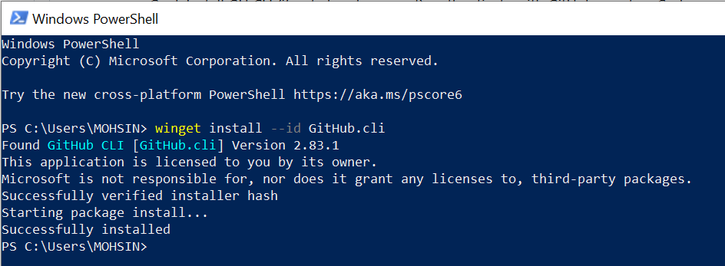
- (Local) Authenticate GH CLI for Codespaces:
gh auth login -s codespace
  - When prompted, generate a GitHub Access Token (classic) in the browser with the following Token scopes:
    - admin:org
    - codespace
    - repo
  - Copy the token into the GH CLI prompt to complete login.
  - Save screenshot as: task1_gh_auth_login.png — screenshot of gh auth login confirmation (redact token).
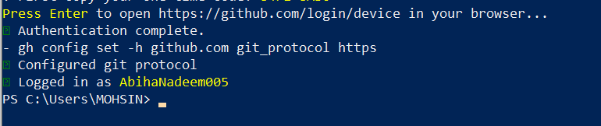
Note: If your organization enforces SSO or device MFA, follow the organization's flow.
- (Local) List available Codespaces (optional verification):
gh codespace list
  - Save screenshot as: task1_codespace_list.png — gh codespace list output (show codespace name).
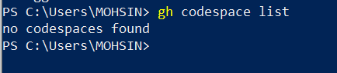
- (Local) Create or connect to a Codespace. To create a new codespace from the current repo:
gh codespace create --repo <owner>/<repo> --branch main --machine basicLinux32gb
Or to open an existing codespace:
gh codespace ssh -c <name_of_codespace>
  - After connecting via gh codespace ssh, you will be inside a Linux shell that the rest of this lab assumes.
  - Save screenshot as: task1_codespace_ssh_connected.png — terminal inside the Codespace shell after gh codespace ssh -c <name>.

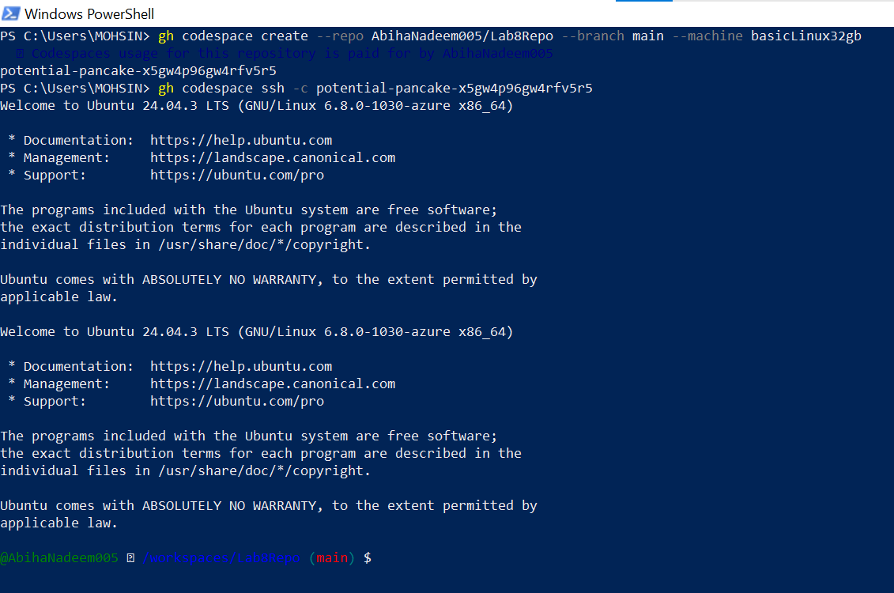

Task 2 — Install AWS CLI inside the Codespace and configure it
Goal: Install the AWS CLI in the Codespace and configure it to interact with your AWS account.
Inside the Codespace shell run:
- Download and install AWS CLI:
- curl "https://awscli.amazonaws.com/awscli-exe-linux-x86_64.zip" -o "awscliv2.zip"
- unzip awscliv2.zip
sudo ./aws/install
  - Save screenshot as: task2_aws_install_and_version.png — terminal showing the download/unzip/install output.
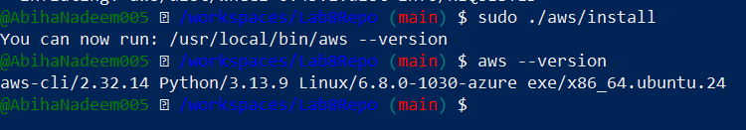
- Verify installation:
aws --version
  - Save screenshot as: task2_aws_install_and_version.png — include aws --version output (same file as install output is acceptable).
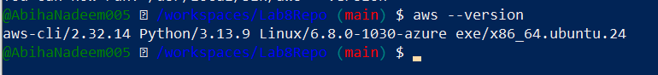
- Configure the AWS CLI (you will provide Access Key ID and Secret Access Key for a user with permissions, or use root/IAM user you prepared for the lab):
aws configure
  - Enter:
    - AWS Access Key ID
    - AWS Secret Access Key
    - Default region name (e.g., me-central-1)
    - Default output format (e.g., json)
  - Save screenshot as: task2_aws_configure_and_files.png — show aws configure prompt (redact secret values if visible).
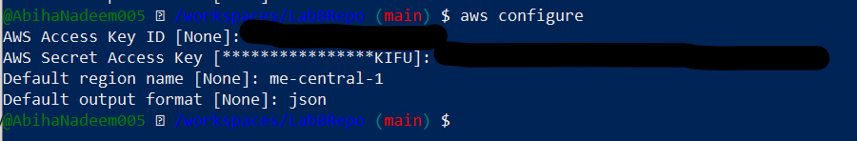
- Verify credentials/config files:
cat ~/.aws/credentials
cat ~/.aws/config
  - Save screenshot as: task2_aws_configure_and_files.png — output of cat commands (redact secrets).
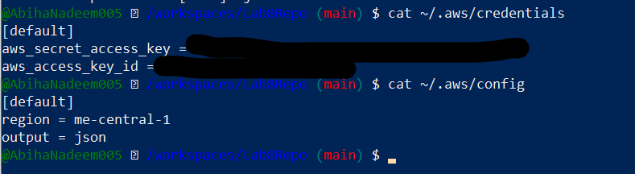
- Verify connectivity (you should see a JSON result showing your caller identity):
aws sts get-caller-identity
Expected output (example):
{
"UserId": "EXAMPLEUSERID1234567890",
"Account": "123456789012",
"Arn": "arn:aws:iam::123456789012:user/ExampleUser"
}
  - Save screenshot as: task2_aws_get_caller_identity.png — aws sts get-caller-identity output.
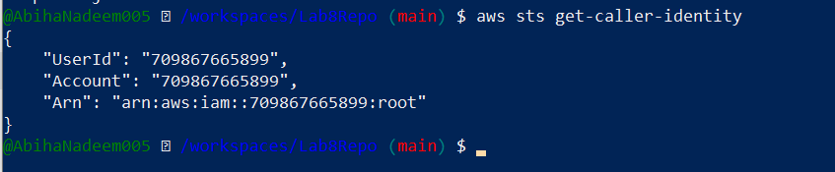

Task 3 — Create security group and add ingress rules using Codespace IP
Goal: Create an EC2 security group, inspect it, add an SSH rule for your Codespace public IP, and verify.
Steps (run in the Codespace shell):
- Create a security group (substitute your VPC id):
- aws ec2 create-security-group --group-name 'MySecurityGroup' \
- --description 'My Security Group' \
- --vpc-id 'vpc-EXAMPLE1234567890'
This command returns a security group id, for example sg-EXAMPLE1234567890.
  - Save screenshot as: task3_create_security_group_output.png — output of create-security-group.
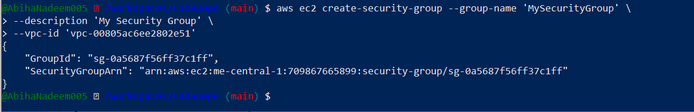
- Inspect the security group (initially ingress will be empty or default):
aws ec2 describe-security-groups --group-ids sg-EXAMPLE1234567890
  - Save screenshot as: task3_describe_sg_before_ingress.png — describe-security-groups before adding rules.
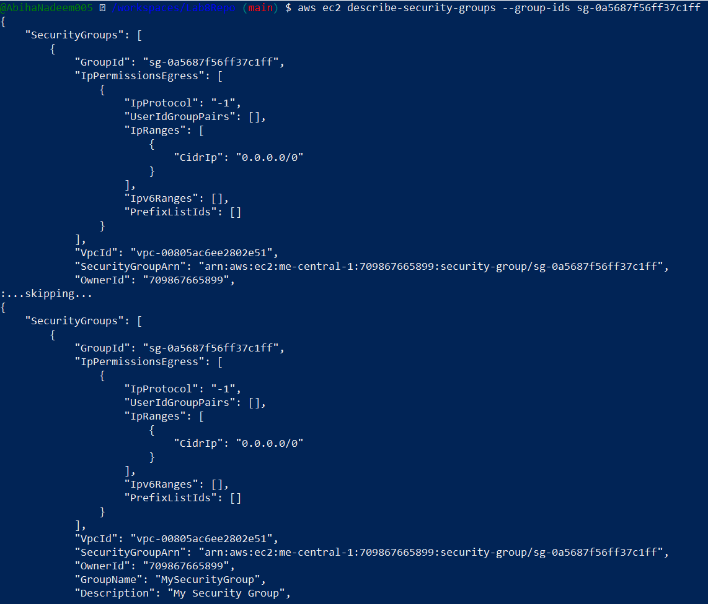
- Get your Codespace public IP (from inside the Codespace):
curl icanhazip.com
  - Save screenshot as: task3_codespace_public_ip.png — output of curl icanhazip.com.
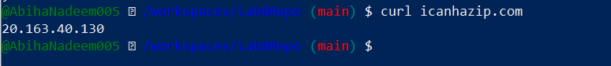
- Authorize SSH inbound on port 22 from your Codespace IP:
- aws ec2 authorize-security-group-ingress \
- --group-id sg-EXAMPLE1234567890 \
- --protocol tcp \
- --port 22 \
- --cidr <XXX.XXX.XXX.XXX>/32
  - Save screenshot as: task3_authorize_ssh_and_describe.png — authorize-security-group-ingress for SSH and subsequent describe output.
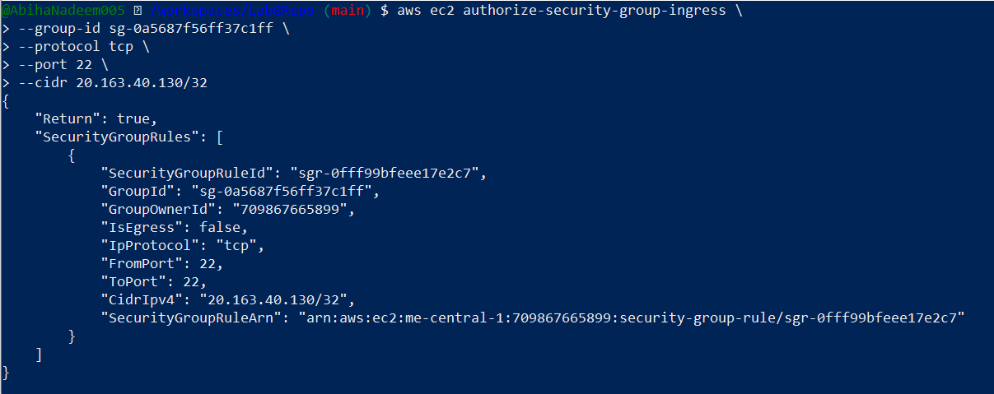
- Verify ingress rule appears:
aws ec2 describe-security-groups --group-ids sg-EXAMPLE1234567890
  - Save screenshot as: task3_authorize_ssh_and_describe.png — describe output showing SSH ingress (same file as previous step is acceptable).
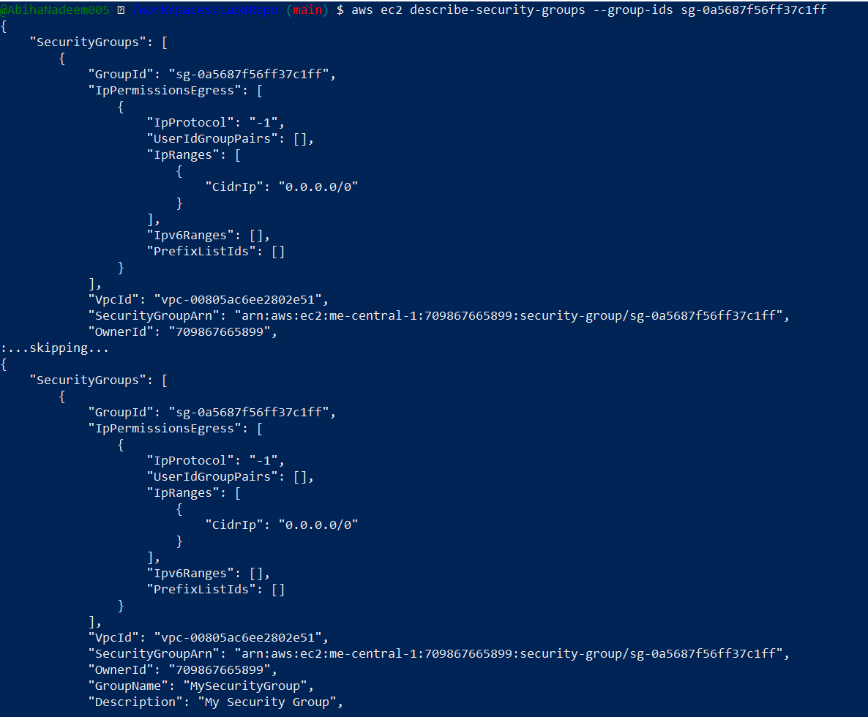
- Add an HTTP rule (port 80) using ip-permissions JSON:
- aws ec2 authorize-security-group-ingress \
- --group-id 'sg-EXAMPLE1234567890' \
- --ip-permissions '{"FromPort":80,"ToPort":80,"IpProtocol":"tcp","IpRanges":[{"CidrIp":"<XXX.XXX.XXX.XXX>/32"}]}'
  - Save screenshot as: task3_authorize_http_and_describe.png — HTTP ip-permissions command and response.
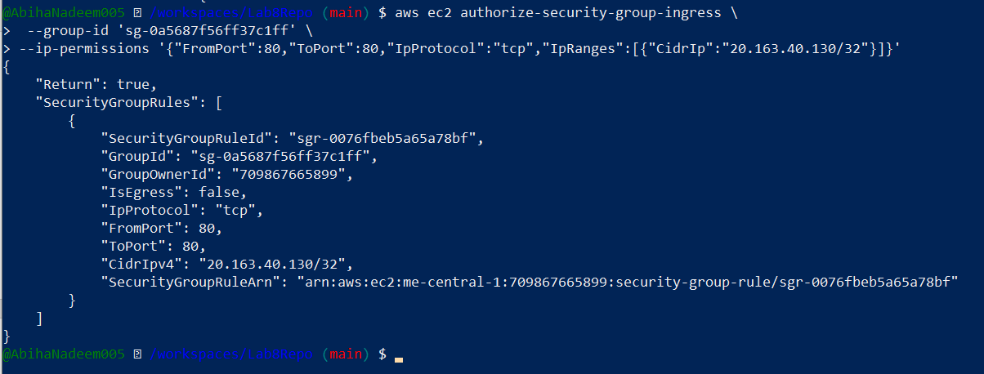
- Verify both ingress rules are present:
aws ec2 describe-security-groups --group-ids sg-EXAMPLE1234567890
  - Save screenshot as: task3_describe_sg_final.png — final describe showing both ingress rules.
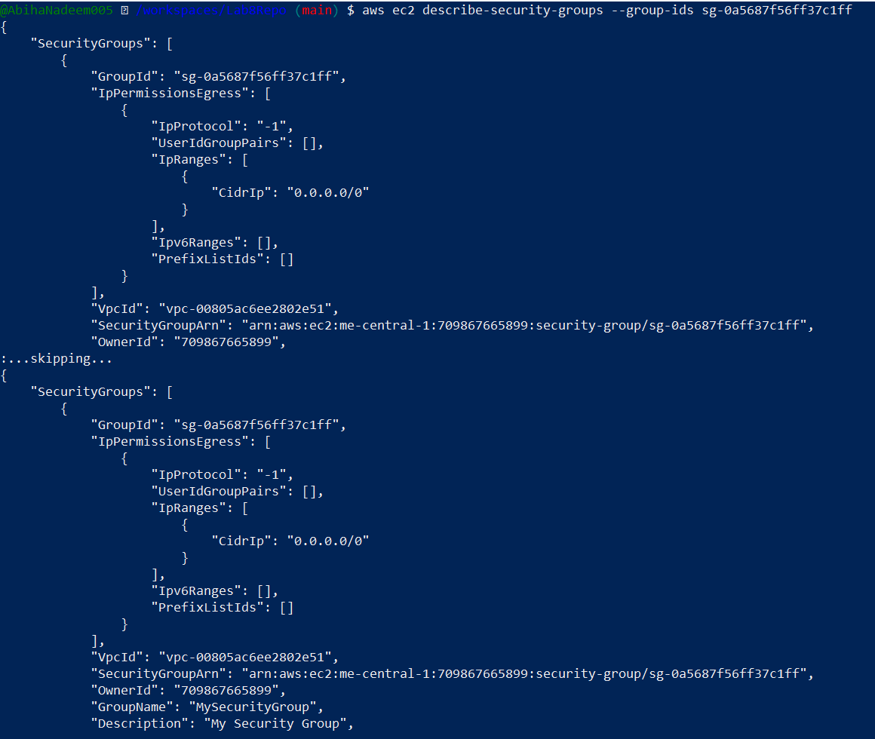
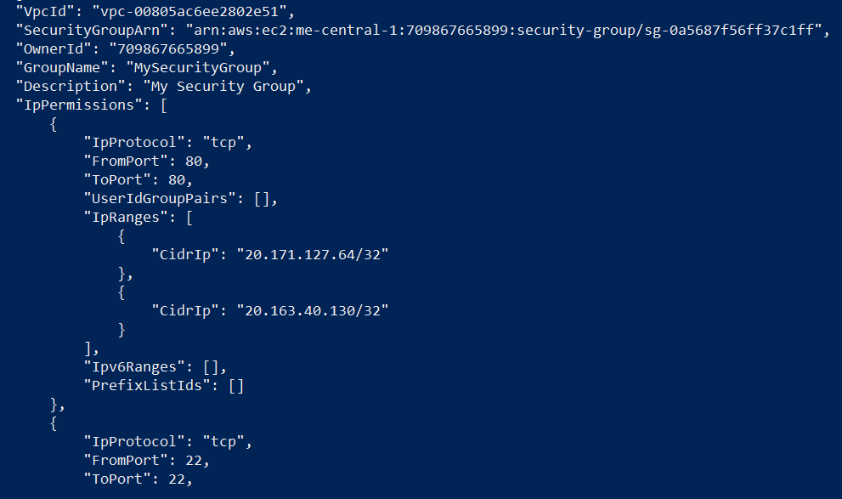

Task 4 — Create a key pair, describe key pairs, and launch EC2 instance
Goal: Create an ED25519 key pair, view it, and launch an EC2 instance using the key pair and the security group created earlier.
Steps:
- Create the key pair and save the PEM file into the Codespace workspace:
- aws ec2 create-key-pair \
- --key-name MyED25519Key \
- --key-type ed25519 \
- --key-format pem \
- --query 'KeyMaterial' \
- --output text > MyED25519Key.pem
  - Save screenshot as: task4_create_keypair_output.png — output of create-key-pair and ls -l MyED25519Key.pem.

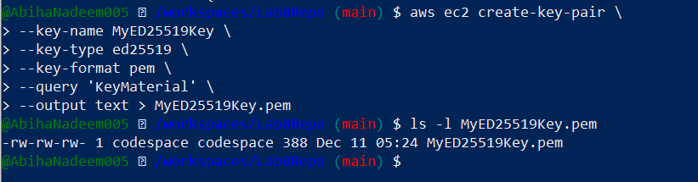
- View created key pairs:
aws ec2 describe-key-pairs
  - Save screenshot as: task4_describe_keypairs.png — describe-key-pairs output.
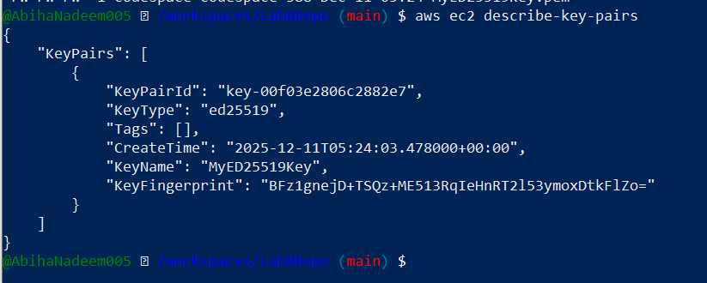
- (Do not) Delete key pair:
aws ec2 delete-key-pair --key-name MyED25519Key # Info: shows how to delete
  - Save screenshot as: task4_delete_keypair_optional.png — output of delete-key-pair (if performed).
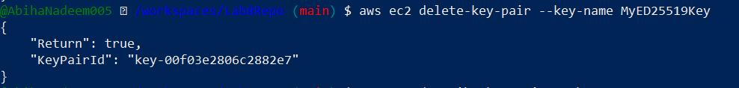
- Launch an EC2 instance (example values — replace IDs with ones from your account/region):
- aws ec2 run-instances \
- --image-id ami-05e66df2bafcb7dea \
- --count 1 \
- --instance-type t3.micro \
- --key-name MyED25519Key \
- --security-group-ids sg-EXAMPLE1234567890 \
- --subnet-id subnet-EXAMPLE1234567890 \
- --tag-specifications "ResourceType=instance,Tags=[{Key=Name,Value=MyServer}]"
  - Save screenshot as: task4_run_instances_output.png — run-instances output with instance id.
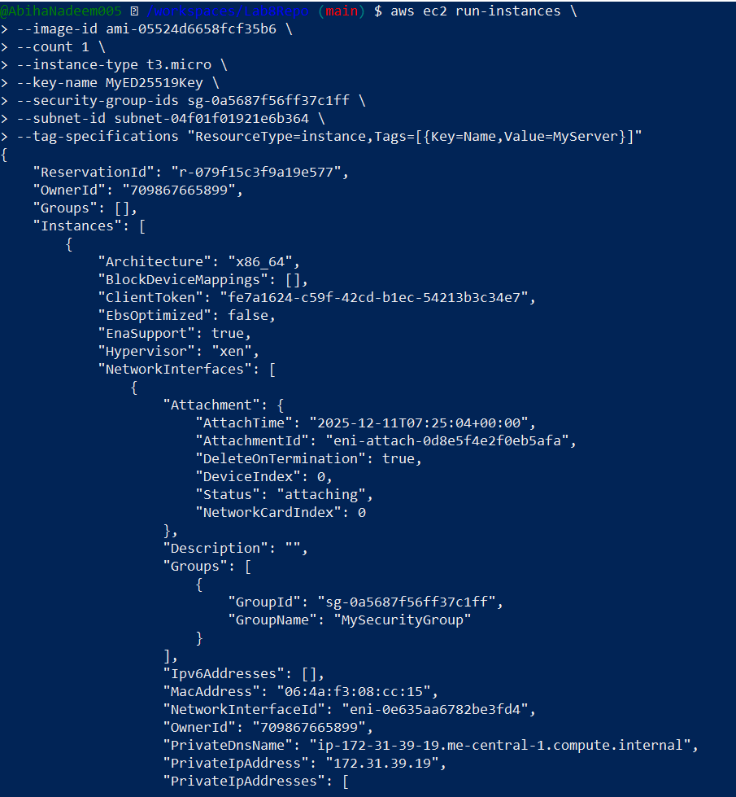
- Get the public IP address of your instance:
- aws ec2 describe-instances \
- --query "Reservations[*].Instances[*].[InstanceId,PublicIpAddress]" \
- --output table
  - Save screenshot as: task4_describe_instances_public_ip.png — describe-instances table with public IP.
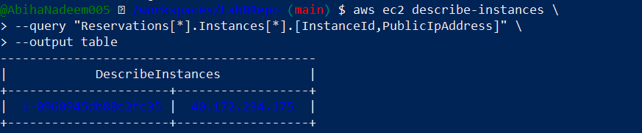
- Attempt SSH into the instance from the Codespace or from a machine whose IP is allowed in the security group:
ssh -i MyED25519Key.pem ec2-user@<public-ip-address>
  - If you see the error:
  - Permissions 0644 for 'MyED25519Key.pem' are too open.It is required that your private key files are NOT accessible by others.
fix permissions:
chmod 400 MyED25519Key.pem
ssh -i MyED25519Key.pem ec2-user@<public-ip-address>
  - Save screenshot as: task4_ssh_permission_error_and_fix.png — show permission error and chmod 400 then successful SSH (redact sensitive details).
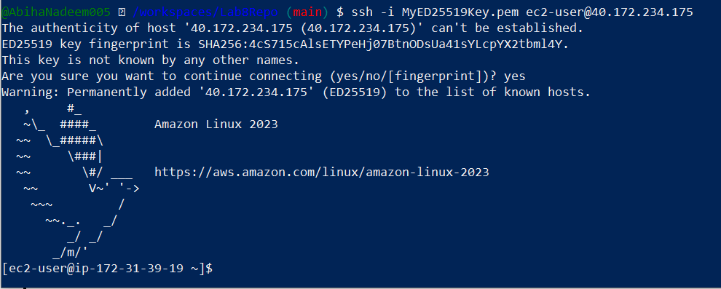

- Stop, start and (optionally) terminate the instance:
- aws ec2 stop-instances --instance-ids i-EXAMPLE1234567890
- aws ec2 start-instances --instance-ids i-EXAMPLE1234567890
- aws ec2 terminate-instances --instance-ids i-EXAMPLE1234567890 # Don't run this command
  - Save screenshot as: task4_stop_start_terminate_commands.png — outputs for stop/start/terminate.
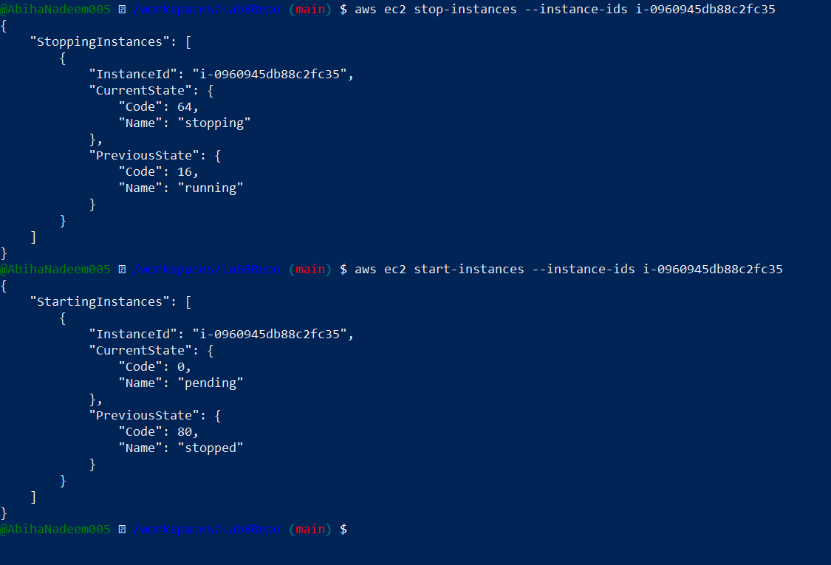

Task 5 — Understand AWS describe-* commands
Goal: Use describe commands to list and inspect AWS resources.
Run and understand these commands (run each, then capture screenshot immediately after):
aws ec2 describe-security-groups
- Save screenshot as: task5_describe_security_groups.png — output of describe-security-groups.
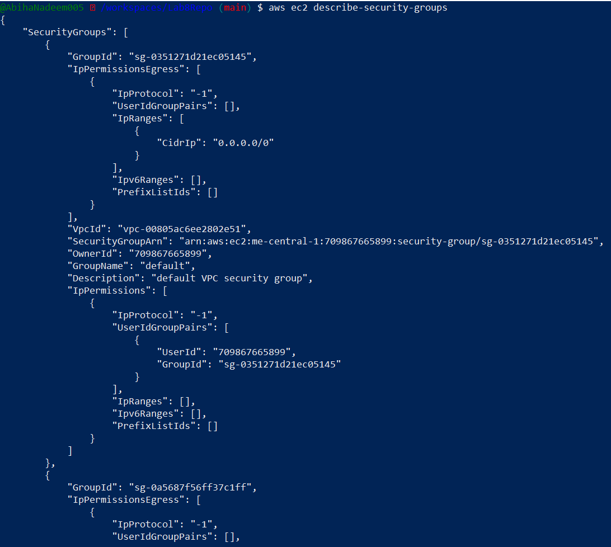
aws ec2 describe-vpcs
- Save screenshot as: task5_describe_vpcs.png — output of describe-vpcs.
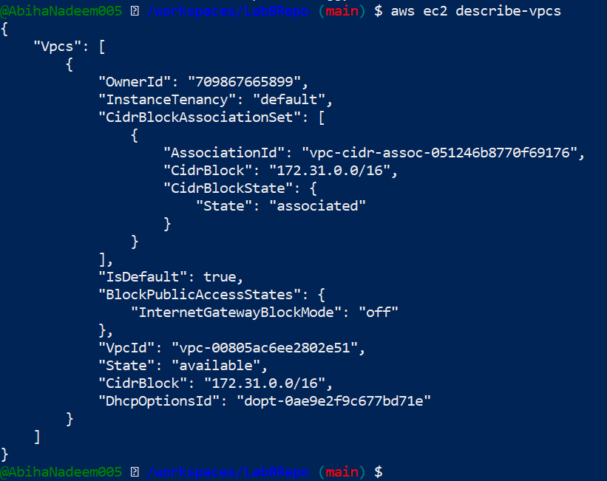
aws ec2 describe-subnets
- Save screenshot as: task5_describe_subnets.png — output of describe-subnets.
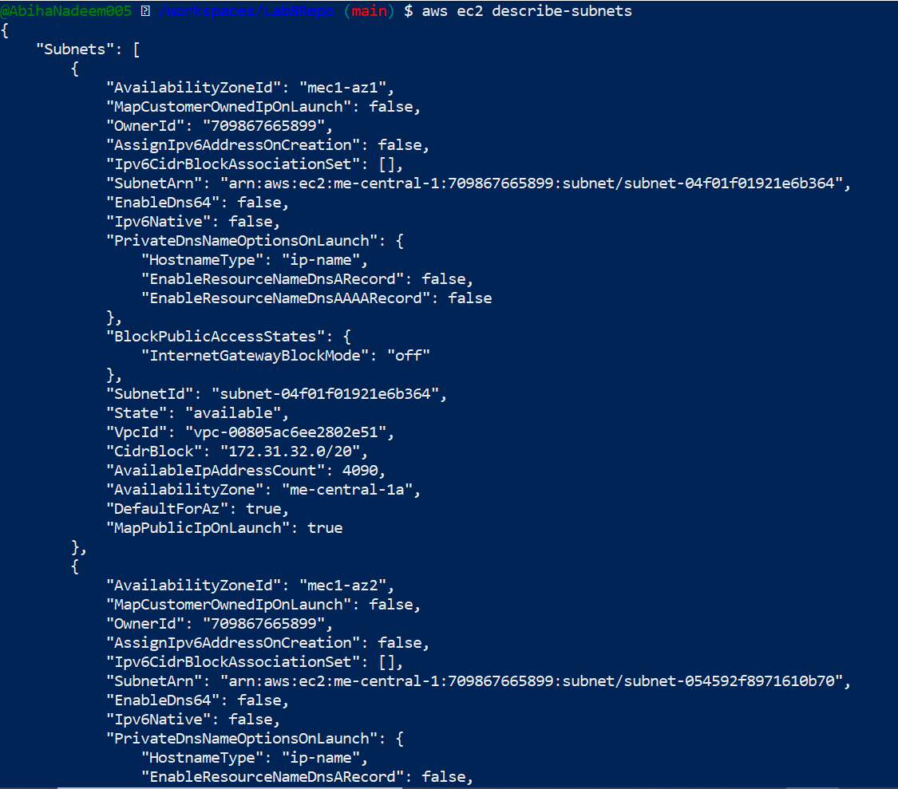
aws ec2 describe-instances
- Save screenshot as: task5_describe_instances.png — output of describe-instances.
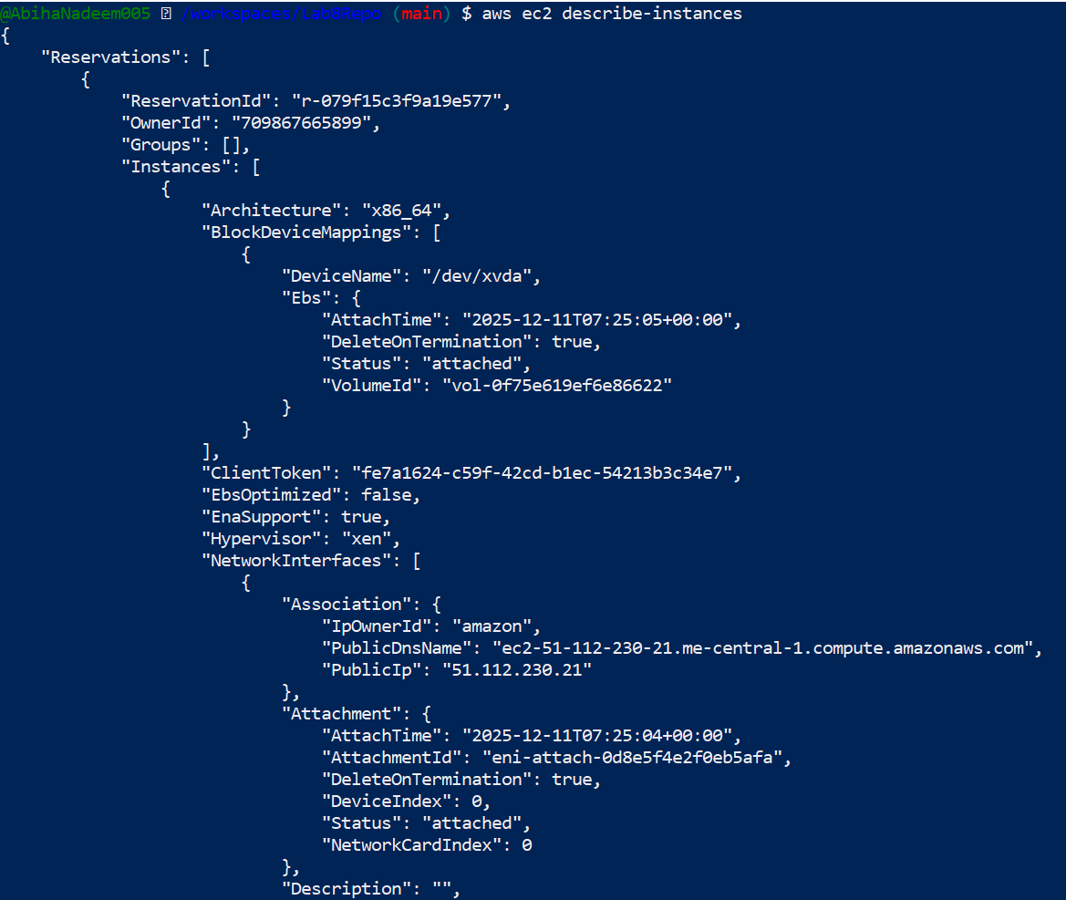
aws ec2 describe-regions
- Save screenshot as: task5_describe_regions.png — output of describe-regions.
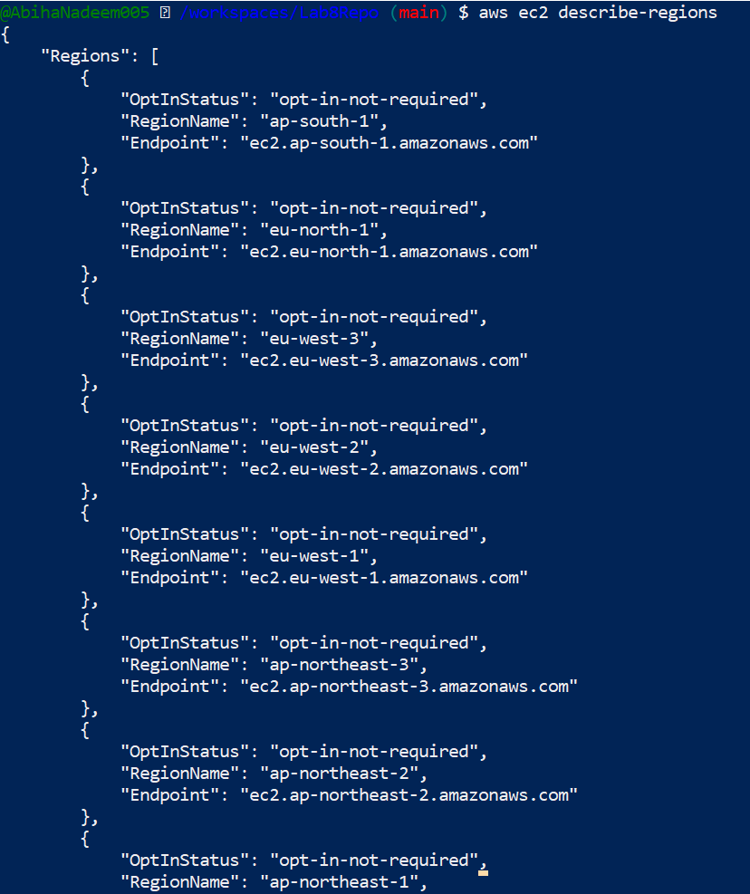
aws ec2 describe-availability-zones
- Save screenshot as: task5_describe_availability_zones.png — output of describe-availability-zones.
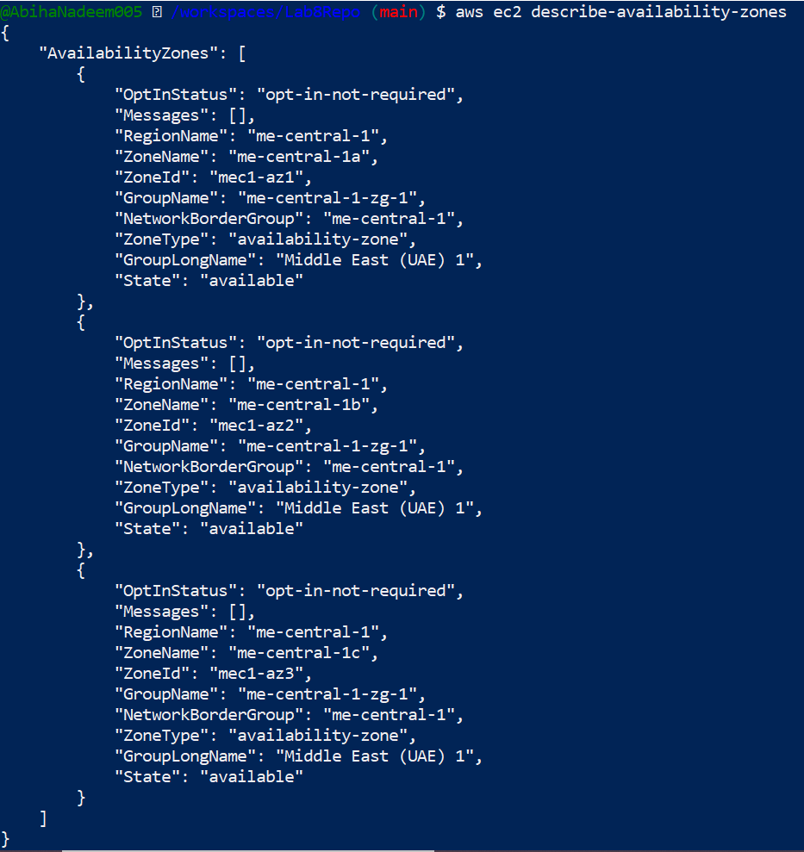

Task 6 — IAM: create group, user, attach policies, create console login & keys
Goal: Practice managing IAM via CLI: create group and user, attach policies, add user to group, create login profile, attach/detach change-password policy, create access keys, and test access via environment variables.
Commands and immediate screenshot request after each step:
- Create group:
aws iam create-group --group-name MyGroupCli
  - Save screenshot as: task6_create_group_and_user.png — create-group output.
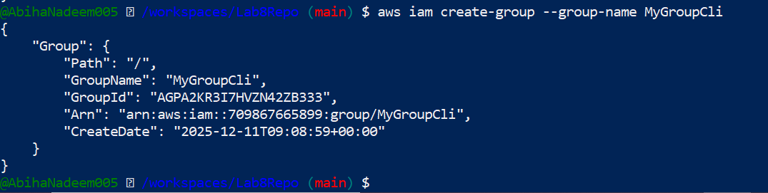
- Get group details:
aws iam get-group --group-name MyGroupCli
  - Save screenshot as: task6_create_group_and_user.png — get-group output.
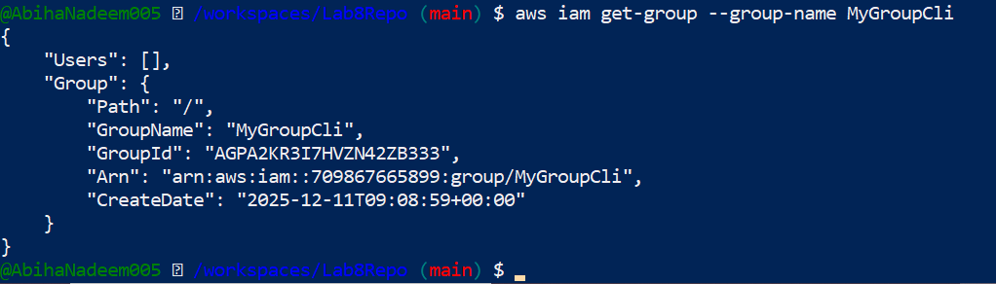
- Create user:
aws iam create-user --user-name MyUserCli
  - Save screenshot as: task6_create_group_and_user.png — create-user output.
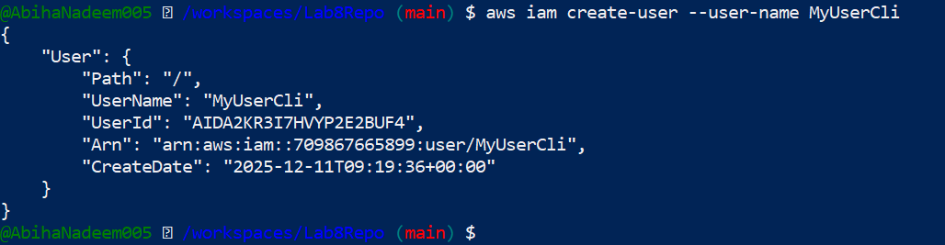
- Get user details:
aws iam get-user --user-name MyUserCli
  - Save screenshot as: task6_create_group_and_user.png — get-user output.
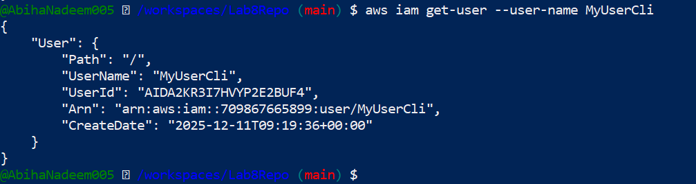
- Add user to group:
aws iam add-user-to-group --user-name MyUserCli --group-name MyGroupCli
  - Save screenshot as: task6_add_user_to_group_and_verify.png — add-user-to-group and verify with get-group.
- See group again:
aws iam get-group --group-name MyGroupCli
  - Save screenshot as: task6_add_user_to_group_and_verify.png — get-group showing user present.
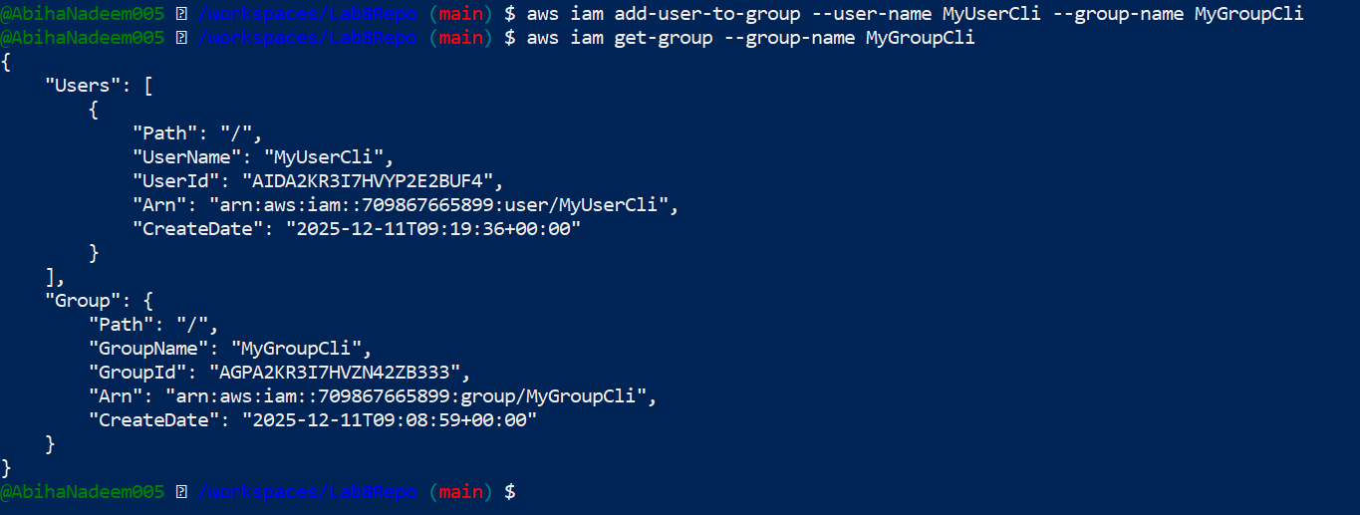
- List policies that mention EC2:
- aws iam list-policies \
- --query "Policies[?contains(PolicyName, 'EC2')].{Name:PolicyName}" \
- --output text
  - Save screenshot as: task6_policy_list_and_attach.png — policy list output.
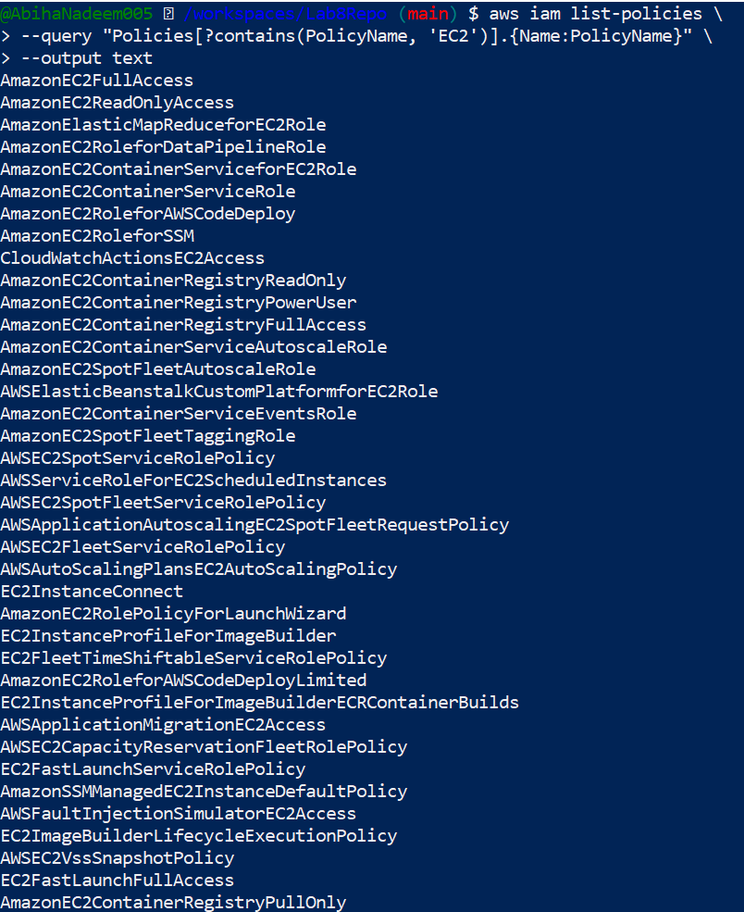
- Get ARN for AmazonEC2FullAccess (example query):
- aws iam list-policies --query 'Policies[?PolicyName==`AmazonEC2FullAccess`].{Name:PolicyName, ARN:Arn}' --output table
  - Save screenshot as: task6_policy_list_and_attach.png — ARN query output.
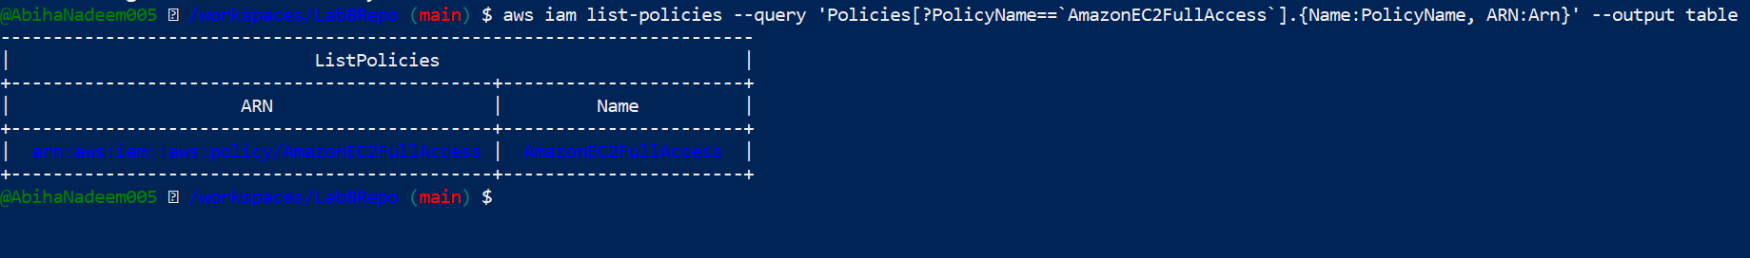
- Attach policy to group (use the ARN you retrieved):
- aws iam attach-group-policy \
- --group-name MyGroupCli \
- --policy-arn arn:aws:iam::aws:policy/EXAMPLEPolicyName
  - Save screenshot as: task6_policy_list_and_attach.png — attach-group-policy output.
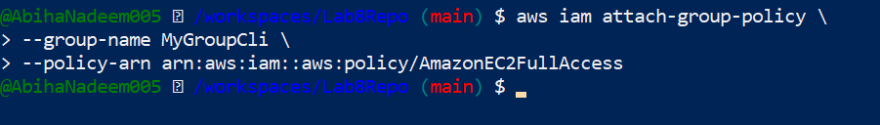
- List attached policies for the group:
- aws iam list-attached-group-policies --group-name MyGroupCli
  - Save screenshot as: task6_policy_list_and_attach.png — list-attached-group-policies output.
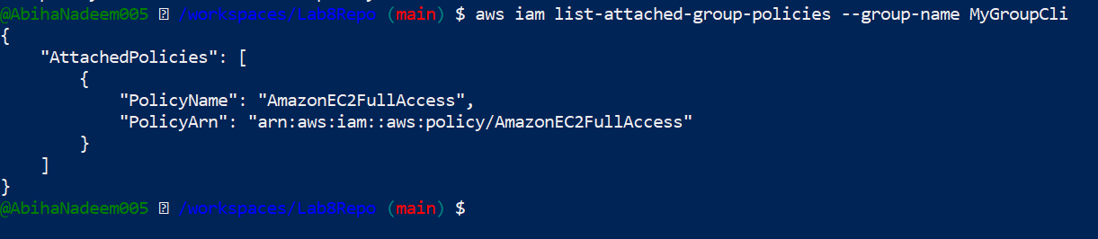
- Create a console login profile for the user:
- aws iam create-login-profile \
- --user-name MyUserCli \
- --password <PASSWORD_VALUE> \
- --password-reset-required
  - Save screenshot as: task6_create_login_profile_and_signin.png — create-login-profile output (do not show password).
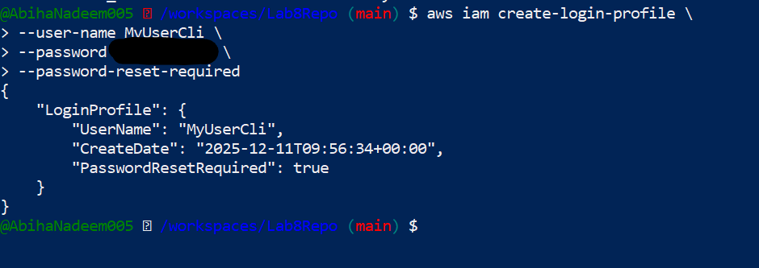
- If the user cannot change password, attach IAMUserChangePassword to the group temporarily:
- aws iam attach-group-policy --group-name MyGroupCli --policy-arn arn:aws:iam::aws:policy/IAMUserChangePassword
After the user logs in and resets password, detach that policy:
- aws iam detach-group-policy --group-name MyGroupCli --policy-arn arn:aws:iam::aws:policy/IAMUserChangePassword
  - Save screenshot as: task6_create_login_profile_and_signin.png — attach/detach outputs and a screenshot showing the user login (redact password).
- Create access keys for the user (save AccessKeyId and SecretAccessKey securely):
- aws iam create-access-key --user-name MyUserCli
  - Save screenshot as: task6_create_access_key_output.png — create-access-key output (redact keys).
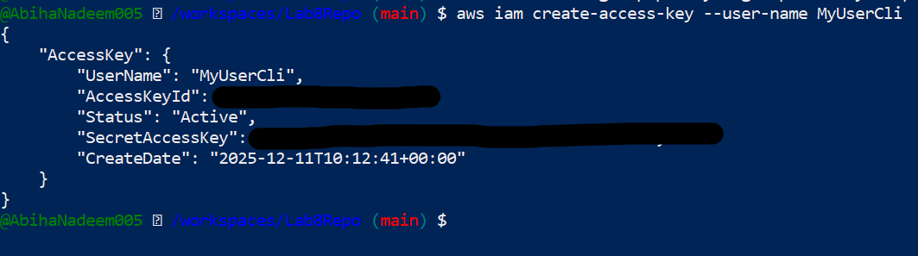
- List access keys:
aws iam list-access-keys --user-name MyUserCli
  - Save screenshot as: task6_create_access_key_output.png — list-access-keys output.
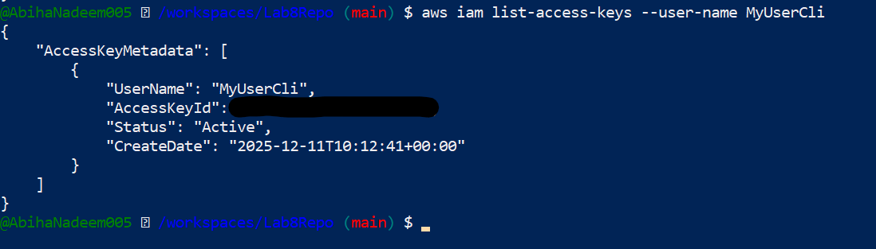
- (Don't) Delete access key:
- aws iam delete-access-key --user-name MyUserCli --access-key-id <AccessKeyId> # Don't run this command
  - Save screenshot as: task6_create_access_key_output.png — delete-access-key output (if performed).
- Use environment variables to authenticate as that user in the Codespace:
- export AWS_ACCESS_KEY_ID=<YOUR_ACCESS_KEY_ID>
- export AWS_SECRET_ACCESS_KEY=<YOUR_SECRET_ACCESS_KEY>
- printenv | grep AWS_
- aws iam get-user --user-name MyUserCli # may fail if no permissions
- exit # to clear exports
  - Save screenshot as: task6_env_exports_and_get_user_error.png — show env exports and any AccessDenied error (if occurs).
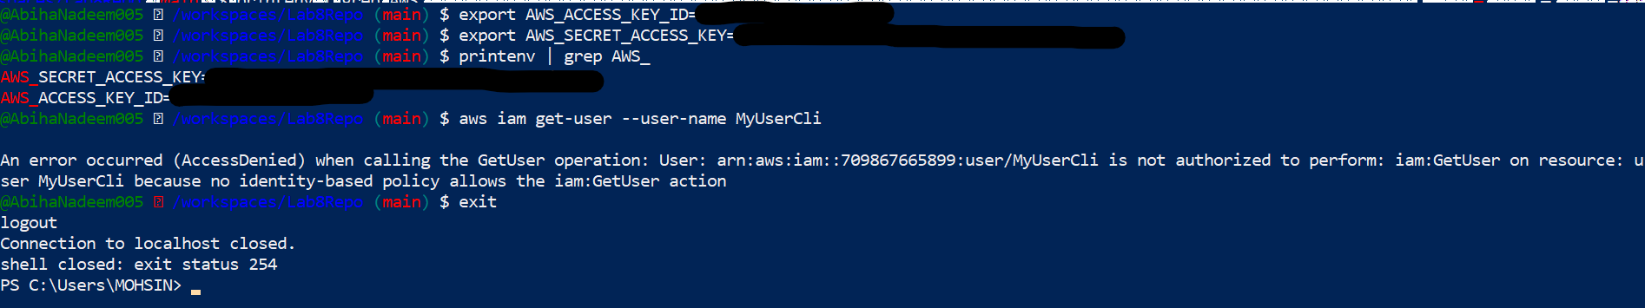
  - After clearing or switching credentials, repeat get-user and save:
    - Save screenshot as: task6_after_logout_and_get_user_success.png — successful get-user output under appropriate credentials.
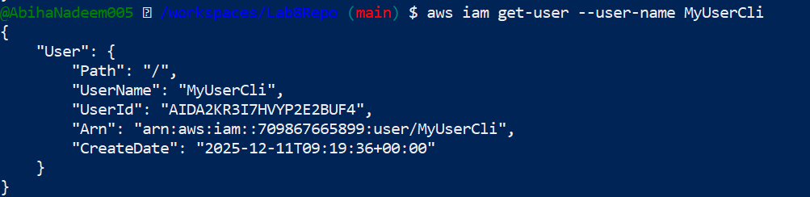

Task 7 — Filters: query with filters to find instances and their attributes
Goal: Use filters and queries to list specific instances and attributes.
Examples (run each and take a screenshot immediately after):
aws ec2 describe-instances \
--filters "Name=tag:Name,Values=MyServer" \
--query "Reservations[*].Instances[*].PublicIpAddress" \
--output text
- Save screenshot as: task7_filter_by_tag_public_ip.png — output of the filter by tag showing public IP.
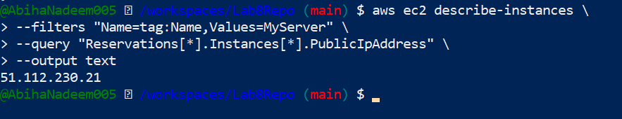
aws ec2 describe-instances \
--filters "Name=instance-type,Values=t3.micro" \
--query "Reservations[].Instances[].InstanceId" \
--output table
- Save screenshot as: task7_filter_by_instance_type.png — output listing instance IDs.

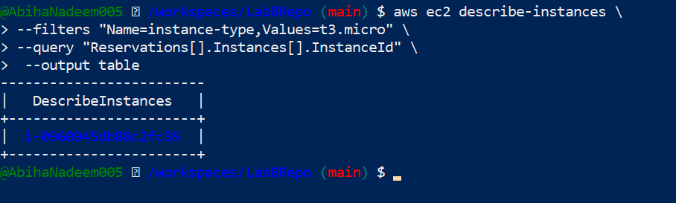
aws ec2 describe-instances \
--filters "Name=subnet-id,Values=subnet-0600df5fa8ce60857" \
--query "Reservations[*].Instances[*].InstanceId" \
--output table
- Save screenshot as: task7_filter_by_subnet.png — output for subnet filter.
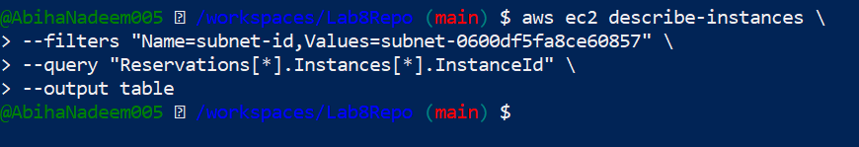
aws ec2 describe-instances \
--filters "Name=vpc-id,Values=vpc-06be85cd81b657192" \
--query "Reservations[*].Instances[*].InstanceId" \
--output table
- Save screenshot as: task7_filter_by_vpc.png — output for VPC filter.
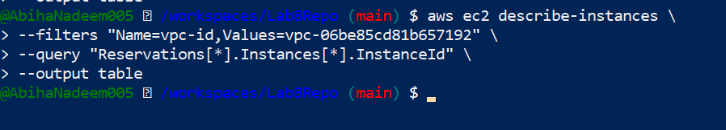

Task 8 — Use --query to format outputs for reporting
Goal: Extract useful fields in table format for reporting.
Examples (run each and take a screenshot immediately after):
- aws ec2 describe-instances \
- --filters "Name=tag:Name,Values=MyServer" \
- --query "Reservations[*].Instances[*].[InstanceId,PublicIpAddress,Tags[?Key=='Name'].Value|[0]]" \
- --output table
- Save screenshot as: task8_query_table_instances_name_ip.png — table showing InstanceId, PublicIpAddress, Name.
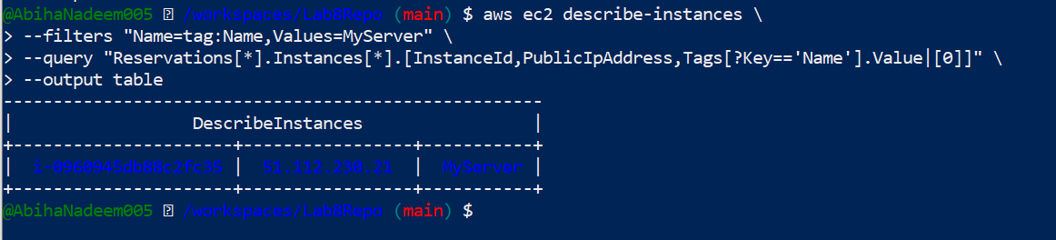
- aws ec2 describe-instances \
- --query "Reservations[*].Instances[*].[InstanceId,State.Name]" \
- --output table
- Save screenshot as: task8_query_table_instance_state.png — table showing InstanceId and State.
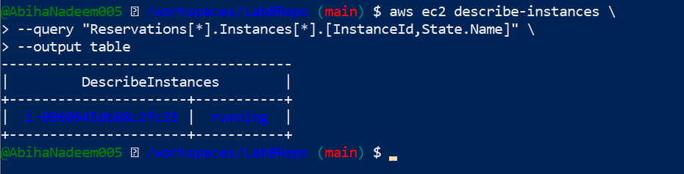
- aws ec2 describe-instances \
- --query "Reservations[*].Instances[*].[InstanceId,InstanceType,Placement.AvailabilityZone]" \
- --output table
- Save screenshot as: task8_query_table_instance_type_az.png — table showing InstanceId, InstanceType, AvailabilityZone.
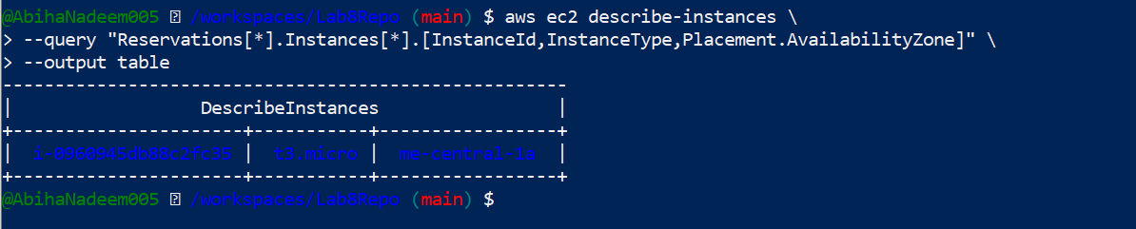

Cleanup — Remove resources to avoid charges
After verification, terminate and delete everything you created in AWS. Capture screenshots for each step.
Cleanup steps and required screenshots (take each screenshot immediately after running the command):
- Terminate instances:
- aws ec2 terminate-instances --instance-ids i-EXAMPLE1234567890
  - Save screenshot as: cleanup_terminate_instance.png — terminate-instances output/confirmation.
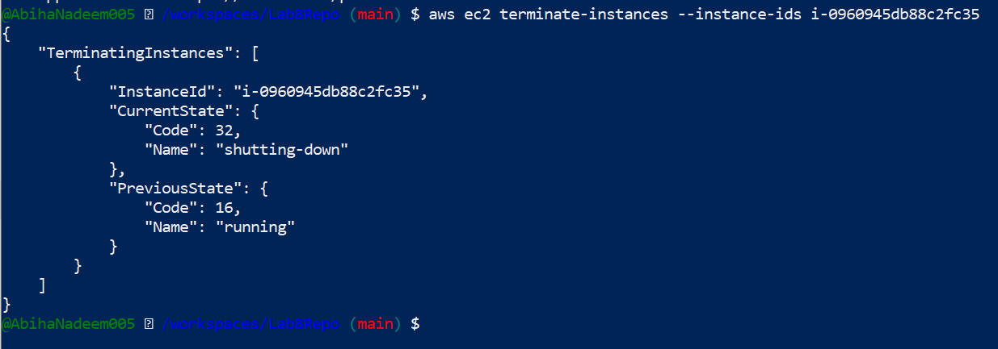
- Delete EBS volumes & snapshots (if any):
  - Save screenshot as: cleanup_delete_volumes_snapshots.png — confirmation or listing showing volumes/snapshots deleted.

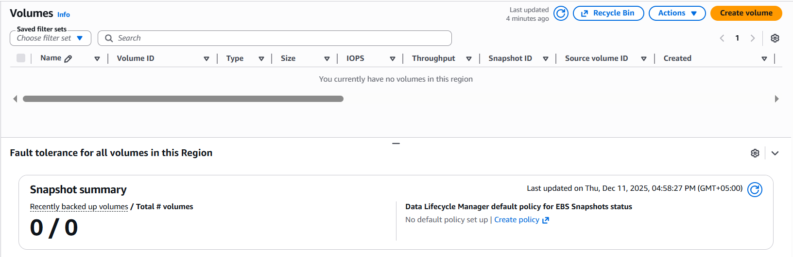
- Delete security group and key pair:
- aws ec2 delete-security-group --group-id sg-EXAMPLE1234567890
- aws ec2 delete-key-pair --key-name MyED25519Key
  - Save screenshot as: cleanup_delete_security_group_and_keypair.png — deletion confirmation(s).
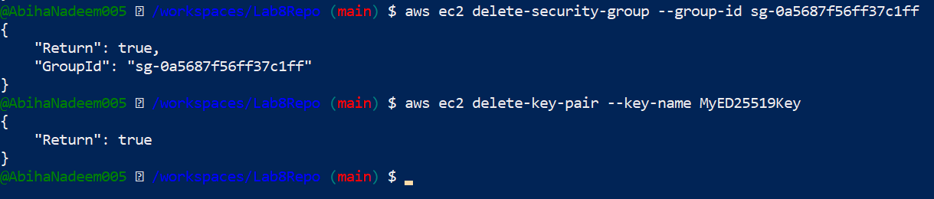
- Remove IAM users, access keys, groups:
- aws iam delete-access-key --user-name MyUserCli --access-key-id <AccessKeyId>
- aws iam delete-login-profile --user-name MyUserCli
- aws iam remove-user-from-group --user-name MyUserCli --group-name MyGroupCli
- aws iam delete-user --user-name MyUserCli
- aws iam detach-group-policy --group-name MyGroupCli --policy-arn arn:aws:iam::aws:policy/EXAMPLEPolicyName
- aws iam delete-group --group-name MyGroupCli
  - Save screenshot as: cleanup_iam_users_deleted.png — IAM deletion commands and confirmation.

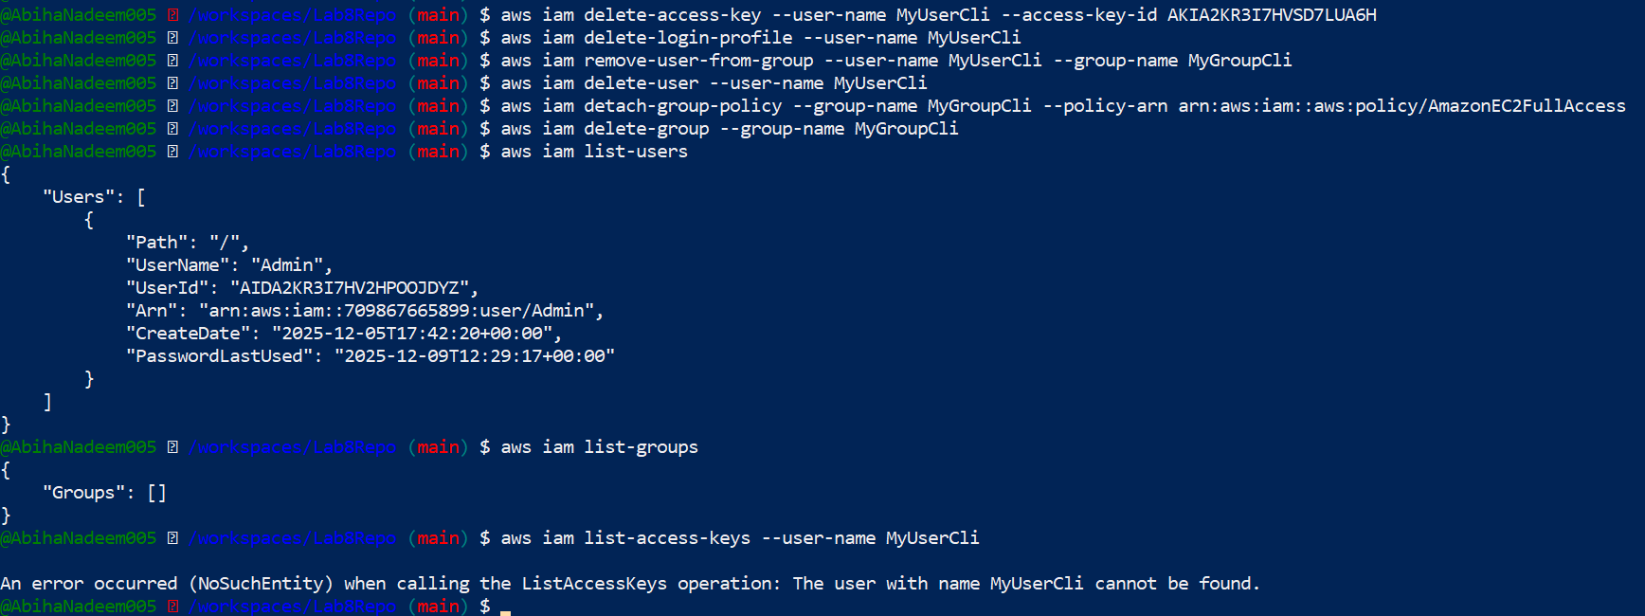
- Final verification (billing/resource groups):
- Save screenshot as: cleanup_summary.png — final console verification (billing/resource groups) showing no active resources if possible.



